DIRECTIVE DATA BREACH


02 FEBRUARY 2023

DIFFUSION LIMITED : INTERNAL
Reference : dpo_dir_02022023_1_en

SUMMARY
1. What is a personal data breach? 3
2. What are the circumstances of a breach? 3
3. What are the legal obligations in case of a data breach? 3
4. How to manager a data breach? 3
4.1. Getting ready 3
Rule 1: Define an internal procedure with the Representative of Security 4
Rule 2: Communicate the internal procedure and standard documents 4
Rule 3: Implement training for employees and crisis team members 4
4.2. Manage the situation 4
5. Appendixes 5
5.1. Definition 5
5.2. Procedure for handling a data breach when Econocom is the Data Controller 5
5.3. Procedure for handling a data breach when Econocom is the Data Processor 6
5.4. Schematic 7
5.5. List of reference documents (available in the Data Protection Village collaborative database) 7

What is a personal data breach?
Personal data breach is defined in Article 4 (12) of the GDPR as a "security breach resulting in :
- Accidentally or unlawfully,
- Destruction,
- Loss,
- Alteration,
- Unauthorized disclosure
of personal data transmitted, stored or otherwise processed, or unauthorized access to such data."

What are the circumstances of a breach?
A security breach may result from:
- A security flaw or vulnerability,
- An accident (fire, hardware failure, earthquake, etc.),
- An error (input, manipulation, system design, etc.),
- A malicious act (phishing, theft of material, external or internal fraud, fraudulent access, data manipulation, logic bomb, malware, site defacement, etc.).
A breach is the concretization of a risk, or even the illustration of a failure to comply with data security obligations (Article 32 GDPR).
Example: security breaches caused by malicious software (resulting in unavailability-ransomware).
- Thus, a personal data breach occurs as a result of a security incident. A security incident can be accidental or unlawful. As stated above, a security incident can result in the destruction, alteration or unauthorized disclosure of personal data.

- These three situations constitute a personal data breach. It can be a breach of confidentiality, availability or integrity:
- A breach of confidentiality is an accidental or unlawful disclosure or access to personal data by an unauthorized third party. Example: loss or theft of computer equipment containing unprotected personal data.
- A breach of availability is the accidental or unlawful loss, destruction or limitation of access to personal data. Example: loss of a USB key.
- A breach of integrity is the accidental or unlawful alteration or modification of personal data.
A single breach may correspond to a combination of several of these categories or to only one.

What are the legal obligations in case of a data breach?
Article 33.1 of the GDPR states: "In the event of a personal data breach, the controller shall notify the competent supervisory authority in accordance with Article 55 of the breach as soon as possible and, if possible, no later than 72 hours after becoming aware of it, unless the breach is unlikely to result in a risk to the rights and freedoms of natural persons.
Article 33.2 of the GDPR states, "The processor shall notify the controller of any personal data breach as soon as possible after becoming aware of it."

How to manager a data breach?

Getting ready
To properly manage a personal data breach, it is necessary to be well prepared to act when it occurs.
Each Econocom entity must apply the following rules.

Rule 1: Define an internal procedure with the Representative of Security
Each Econocom entity must define an internal procedure with its IT Security representative specifying
- The alert system to be activated in the event of the detection of an incident and/or a personal data breach
- The procedure to follow as well as the persons/departments to contact
- The list of the members of the crisis unit
See Template of the Internal Procedure to be adapted for the DPS/DPL

Rule 2: Communicate the internal procedure and standard documents
This procedure should be communicated to the entity's staff.
This procedure shall specify the location of the standard documents to be used for reporting and notifying the violation:
- Breach Report Form
- Sample Breach Log
- Breach Assessment Grid
- Form for notification to the authority
- Model of notification to the Client
- Model of notification to the persons concerned

Rule 3: Implement training for employees and crisis team members

Manage the situation
Rule 4: Gather the crisis unit as soon as the violation is known
The management of a personal data breach requires, depending on the nature of the breach, the mobilization of different actors (Operational Manager, IT Security Department, RGPD Referent, Lawyer, Communication Department, Customer Relationship Manager, HR Manager, ...) who must work together within the framework of a crisis meeting to take the appropriate decisions in a collegial manner.

Rule 5: Apply the internal breach management procedure
- Detect the security incident
- Describe and qualify the incident
- Evaluate the severity of the breach in terms of the impact on people
- Define the remediation measures
- Notify the data controller or notify the Authority
- Notify the data subjects or assist the Data Controller in notifying the data subjects (when Econocom is a subcontractor)
- To put in place the remediation measures and to follow their application
- Trace the incident and the breach in the data breach register

Appendixes

Definition
Data processor
The processor, within the meaning of the GDPR, is the natural or legal person (company or public body) who processes personal data on behalf of another organization (the Data Controller), in the context of a service or provision.
The Econocom entity, in the context of its projects for its Clients, generally acts as a Subcontractor and processes personal data on the instructions formalized by the Client in the Annex "description of the processing" inserted in the contract with the Client.
When it acts as a Subcontractor, Econocom may be informed of an incident by its Data Controller (its Client) or may itself detect an incident.

Data controller
The Data Controller is a legal entity (company, municipality, etc.) that determines the purposes and means of a processing operation, i.e. the purpose of the personal data processing and the way it is carried out.
All of Econocom's entities have a role as Data Controller for certain activities such as website management, video surveillance of premises, badge management, personnel management, etc. These are processing operations that are necessary for the functioning of the entity.

Procedure for handling a data breach when Econocom is the Data Controller
When the Econocom entity is aware of a security incident, it must immediately declare it by sending an email to XXXXXXXX (the entity's security department). The IT Security Department thus receives an alert and conducts an investigation into the reported incident.
Once the investigation is completed by the IT Security Department, a crisis unit will be set up.
The crisis team is made up of the Project Lead, the Data Protection Lead of the Econocom entity concerned, the local IT Security representative, the Data Protection Supervisor and the Group DPO, the Legal Department and the Communications Department.
The crisis unit will qualify the incident as a personal data breach or not. If it is, it will decide on the measures to be taken to manage the situation. In particular, it will prepare a report on the breach with a view to notifying the Authority within 72 hours.
The Econocom entity, as Data Controller, must document any personal data breach. In the event of a breach it must:
- Notify the National Supervisory Authority as soon as possible, and if possible within 72 hours of becoming aware of the breach, if the breach is likely to result in a risk to the rights and freedoms of natural persons
- Inform the persons concerned in case of high risk
The National Supervisory Authority receives the notification and examines the elements related to the breach. It then advises the Econocom entity on the measures to be taken and may order it to communicate the data breach to the persons concerned.
Finally, the data subjects receive the communication of the breach in case of high risk for their rights and freedoms.

Procedure for handling a data breach when Econocom is the Data Processor
When the Econocom entity is aware of a security incident, it must immediately declare it by sending an email to XXXXXXXX (the entity's security department). The IT Security Department thus receives an alert and conducts an investigation into the reported incident.
Once the investigation is completed by the IT Security Department, a crisis unit will be set up by the IT representative in consultation with the DPO/DPS.
The crisis team is made up of the Project Lead, the Data Protection Lead of the Econocom entity concerned, the local IT Security representative, the Data Protection Supervisor and the Group DPO, the Legal Department and the Communications Department.
The crisis team will qualify the incident as a personal data breach or not. If it is, it will decide on the measures to be taken to manage the situation. In particular, it will prepare a report on the breach for notification to the Client.
The Econocom entity as a Data Processor shall notify the Client company (Data Controller) of any personal data breach within the time limits indicated in the contract. If no deadline is indicated, it must inform the Client as soon as possible.
The Client company, as the Data Controller, must document any personal data breach. In the event of a breach it must:
- Notify the National Supervisory Authority as soon as possible, and if possible within 72 hours of becoming aware of the breach
- 2Inform the data subjects in case of high risk
The National Supervisory Authority receives the notification and reviews the elements of the breach. It then advises the Client company on what action to take and may order the Client company to notify the affected individuals of the data breach.
Finally, the data subjects receive the communication of the breach in case of high risk to their rights and freedoms in accordance with Article 34 of the GDPR. This communication must be made by the Controller and not by the Processor.

Schematic
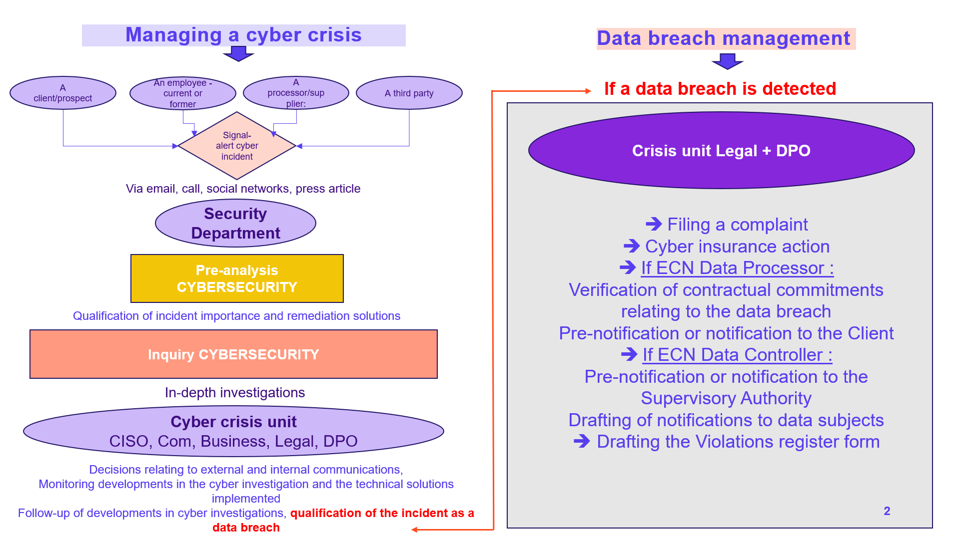
Internal data breach management process

List of reference documents (available in the Data Protection Village collaborative database)
- Procedure for managing a data breach when Econocom is a Data Controller
- Procedure for managing a data breach when Econocom is a Data Processor
- Template data breach register (see tool Data Legal Drive)
- Breach assessment grid (reserved for the crisis team)
- Form for notification of breach to the National Supervisory Authority
- Form for notification of breach to the Client
- Template of breach notification to data subjects

Previous versions
Version | date | AUThor | Type of update
001_en | 02/02/2023 | Danièle LEFUR | Document revised



